Tasmanian Motorcycle Trials Club inc

(The Most Challenging Motorcycle Sport)

President | Vice President | Secretary | Treasurer
Peter Bayles | Kirk Costello | Mark Carter | Rosanne Langworthy
0418 137967 | 0419554840 | 0407516140 | 0417050832
Assistant Treasurer –Annabelle Bayles
1st Aid Kit – Colin Woodberry, Fiona Munday
Committee Members – Colin Woodberry, Brett Langworthy, Nigel Munday, Tim Mead
Craig Ferrall, Mike Luscombe, Neil Berne Snr, Louis Stephens, Harley Pickett
Tony Demeijer, Peter Lockhart.
Scrutineers – Mike Amey, Brett Langworthy & Mark Carter
Publicity Officer – Ian Pickering 0418 131341
Section Checkers – Neil Berne, Peter Bayles, Peter Lockhart
Section Cleanup–Section 1=Clubman, 2 & 3=CGrade, 4=C+Grade, 5=BGrade, 6=A/A+Grade
Life Member – Neil Berne
Observers – Bring an observer! Volunteers to contact Toni Pickering before the Trial

CHANGE of LOCATION ! - Next Trial is at Jericho 23 May
The Trial will be set on Sunday May 16 – come and help if you can

IMPORTANT DATES
SATURDAY 19 June - Confirmed a Training Day for all grades on 19 June at Mt Joy. Tom Scott & Trevor Campbell will be in attendance – come along and learn from the experts!
The Mt Joy Trial is on the following day 20 June

Oatlands Trial
The Oatlands trial was much warmer than I remember the Oatlands trials to be – for a start there was no ice over the creek. We had a perfect winters day with no wind and plenty of sunshine.
It was set in the creek and adjacent hillside, over some rounded sandstone rocks. Section 1 & 2 were in and out of the creek. Section 3 was set around a large fallen tree. Section 4,5 & 6 were on the hillside with sandstone rocks and loose gritty soil.

The migration of the local spiders was in full swing, you could see many spiders floating along on the gentle breeze on a metre long thread of web. Occasionally they were landing on bikes, tents and seats. I hear one of the ladies in the tent had one unwelcome visitor drop down the front of her tea shirt!!!

Expert Grade had some very testing sections in it to keep Chris on his toes. Section 4 had a difficult double step followed by some very tight arrows that required a lot of hopping and bouncing. Chris lost 77 points for the day so it was no picnic.

A Grade had one rider Peter Lockhart who was riding very neatly in the loose shifting dirt.

B Grade had 4 riders – Peter Bayles and Kurt Pickering had a close trial, with each of them riding better in different sections. At the end of the trial Peter was 1st just 3 points ahead of Kurt. Mike Amey was 3rd just ahead of Dylan Bayles in his 1st season in B Grade. Section 5 & 6 with large rocks and dropoff’s took the most points from Mike & Dylan.

C+ Grade had 9 riders. Master rider Neil Berne streeted the field with half the total of 2nd place rider Mike Travica. Yet again Sections 5 & 6 were the difference. Louis Stevens, Ian Pickering & Josh King were all pretty close with only 5 points separating them all. Louis was 3rd and proved that the 4 stroke sherco can do it in the dry as well as the wet. Josh King is continuing to improve in his first season in C+ and will soon be close to a podium.

C Grade had 11 Riders. Damian Langworthy showed everyone a clean pair of heels to finish on ONLY 14 points! Tim Mead was 2nd with a bit of a Jekyll & Hyde ride, most sections were in single digits then a couple of sections with high totals. The potential is there, just need to polish it up a bit. Mike Hull & Craig Ferrell were neck and neck for 3rd, sections 1 & 5 were the the most difference was between them. Congratulations to Mike who was 3rd by just one point!

Harley Pickett & Brian Peacock brought their sidecar and rode well to get it around the sections at Oatlands. They are improving and have an invite to ride the MK1 Loone pivoting sidecar when they go to Victoria.

Clubman had 2 riders. Stacy Langworthy was 1st & Brooke Luscombe 2nd with some very careful riding on display. Both girls were doing a good job of climbing up out of the creek in section 2.
With both of these riders so close, it will take one of them to learn a new skill like slipping the clutch to gain an advantage in the tight corners to separate them.

Fun & Games at the Trial
- Some people have wagered that I would not talk about an incident in the creek I was involved in at Oatlands……..very tempting…… However the truth must be told!
Nigel Munday very kindly offered me a ride on his new 2010 Sherco (thinking I would take care of it, ha ha)
So after taking 5 mins to familiarize myself, I then attempted Section 1 where I entered and crossed the creek and attempted to climb the small bank on the other side….but I did not make it….and began sliding backwards.
So as my life flashed before my eyes and Nigels last words rang in my ears…”You scratch it – you buy it” I desperately tried to save the bike…in doing so I ended up full length in the creek, soaked from top to bottom!
The bike was high and dry on the bank…..but there was a tiny scratch on the ball end of the front brake lever…..how could I hide it from Nigel ?!?
- Mick Luscombe apparently tried out acrobatics as he came back down the steep hill in front of the tent.

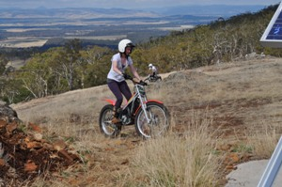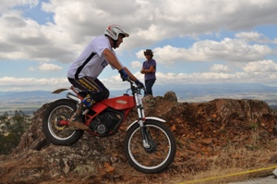
Stacey Langworthy at Mt Joy Nigel Munday on the Fantic
Photo’s thanks to Vonette Mead

Mt Joy Training Day – 2 May
The training day at Mt Joy was attended by about 10 riders. Also 2 new members turned up with bikes - Mike on ex David Catts Scorpa and Lawrence on ex Jack Costello’s Sherco. A 3rd new member also turned up and is still looking for a bike.
I figured out why practice days are more tiring than trials days…..you just keep riding…no breaks waiting for your turn at the next section.
A good day was had by all and some interesting discussion was held around the campfire afterwards.

LESSONS OF THE DAY
Lesson 1 ) The benefit of keeping your feet on the pegs to lower your centre of gravity was one hot topic.
As part of the training day instruction - Chris Bayles demonstrated the pitfalls of raising your centre of gravity to the rest of the riders there. While riding across the lower water filled quarry his feet were getting wet, so he stepped up onto the seat of the bike (raising his centre of gravity). At this moment the bike hit some underwater obstacle and both Chris and the bike went into the deep water for a swim.
Remember to keep your feet on the pegs where ever possible – as sitting down….or standing on the seat, raises your centre of gravity and makes it harder to control the bike.

Lesson 2 ) Chris & Mark Carter demonstrated to the rest of the trials school how to de-water a drowned trials bike. Plug out, water out of airbox engine and exhaust, air cleaner off and cleaned, gearbox oil changed.

As you can see we all learned a lot from this Trials training day

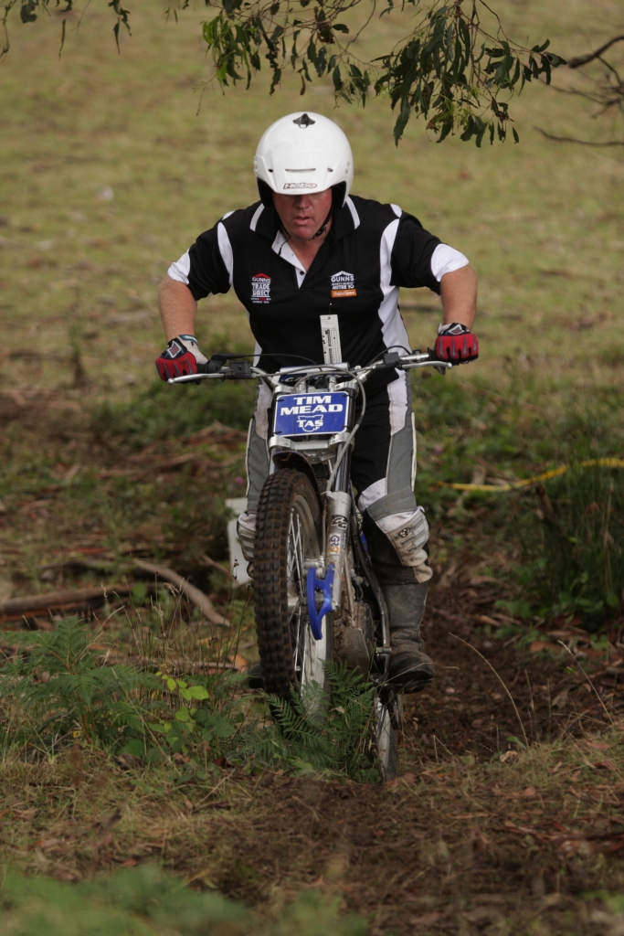  Tim Mead at Mole Creek – staying on line | TMTC Peak Hats  Thanks to Teena Medwin we now have a fresh supply of TMTC Club Colour Peak Hats.  They are a quality item and they are big enough to fit a large head. Cost is $20.  See the Ladies in the tent at the next trial…..going pretty quick!  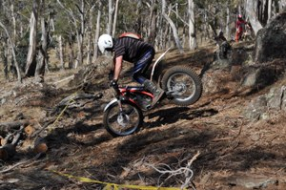  Soooo – Peter Bayles can hop the rear wheel !

VENUE: | Oatlands |  |  |  |  | DATE: | 18/04/2010
Expert | 1 | 2 | 3 | 4 | 5 | 6 | 7 | TOTAL | BIKE | PLACING
Chris Bayles | 8 | 17 | 3 | 26 | 10 | 13 | 0 | 77 | Gas Gas 250 | 1
A Grade | 1 | 2 | 3 | 4 | 5 | 6 | 7 | TOTAL | BIKE | PLACING
Peter Lockhart | 3 | 13 | 11 | 13 | 10 | 5 | 0 | 55 | Gas Gas 250 | 1
B Grade | 1 | 2 | 3 | 4 | 5 | 6 | 7 | TOTAL | BIKE | PLACING
Peter Bayles | 1 | 0 | 12 | 7 | 8 | 7 | 0 | 35 | Gas Gas | 1
Kurt Pickering | 3 | 2 | 4 | 3 | 14 | 12 | 0 | 38 | Gas Gas | 2
Mike Amy | 8 | 9 | 9 | 6 | 18 | 14 | 0 | 64 | Gas Gas | 3
Dylan Bayles | 5 | 3 | 16 | 9 | 30 | 23 | 0 | 86 | Gas Gas | 4
C+ Grade | 1 | 2 | 3 | 4 | 5 | 6 | 7 | TOTAL | BIKE | PLACING
Neil Berne Snr | 2 | 0 | 2 | 4 | 4 | 0 | 0 | 12 | Beta 250 | 1
Mike Travica | 0 | 1 | 2 | 4 | 9 | 7 | 0 | 23 | Sherco | 2
Louis Stevens | 5 | 0 | 2 | 14 | 6 | 5 | 0 | 32 | Sherco 320 | 3
Ian Pickering | 6 | 5 | 3 | 8 | 11 | 2 | 0 | 35 | Gas Gas | 4
Josh King | 8 | 5 | 0 | 10 | 14 | 0 | 0 | 37 | Beta 250 | 5
Nigel Munday | 8 | 5 | 0 | 12 | 14 | 6 | 0 | 45 | Sherco | 6
Dave Waller Jnr | 4 | 8 | 7 | 17 | 15 | 4 | 0 | 55 | Sherco 250 | 7
Mick Luscombe | 15 | 4 | 9 | 13 | 12 | 7 | 0 | 60 | Sherco 290 | 8
Tony Demeijer | 14 | 16 | 10 | 11 | 12 | 5 | 0 | 68 | Montesa | 9
C Grade | 1 | 2 | 3 | 4 | 5 | 6 | 7 | TOTAL | BIKE | PLACING
Damian Langworthy | 6 | 0 | 0 | 0 | 5 | 3 | 0 | 14 | Gas Gas 250 | 1
Tim Mead | 10 | 1 | 4 | 1 | 5 | 11 | 0 | 32 | Gas Gas | 2
Mike Hull | 14 | 5 | 4 | 2 | 7 | 3 | 0 | 35 | Sherco | 3
Craig Ferrall | 7 | 1 | 9 | 0 | 16 | 3 | 0 | 36 | Gas Gas 250 | 4
Brett Langworthy | 9 | 0 | 9 | 2 | 8 | 13 | 0 | 41 | Gas Gas 250 | 5
Dave Wendell - Smith | 16 | 5 | 13 | 5 | 9 | 6 | 0 | 54 | Sherco 250 | 6
Mark Carter | 9 | 3 | 11 | 7 | 13 | 12 | 0 | 55 | Beta Evo 250 | 7
Bradley Shadbolt | 17 | 1 | 16 | 7 | 9 | 8 | 0 | 58 | Gas Gas 80 | 8
David Catt | 19 | 1 | 16 | 7 | 7 | 15 | 0 | 65 | Scorpa | 9
Ron Leistra | 21 | 6 | 12 | 12 | 16 | 8 | 0 | 75 | Sherco 290 | 10
Kurt Peacock | 26 | 15 | 26 | 17 | 22 | 25 | 0 | 131 | Sherco 250 | 11
Twin Shock | 1 | 2 | 3 | 4 | 5 | 6 | 7 | TOTAL | BIKE | PLACING
Clubman | 1 | 2 | 3 | 4 | 5 | 6 | 7 | TOTAL | BIKE | PLACING
Stacy Langworthy | 12 | 5 | 0 | 0 | 6 | 0 | 0 | 23 | Beta 80 | 1
Brooke Luscombe | 14 | 11 | 1 | 1 | 0 | 3 | 0 | 30 | Suzuki RL 250 | 2
Sidecars | 1 | 2 | 3 | 4 | 5 | 6 | 7 | TOTAL | BIKE | PLACING
Harley Pickett & Brian Peacock | 26 | 11 | 20 | 25 | 0 | 0 | 0 | 82 | Gas Gas 300 | 1

WANTED TO BUY
Trials Bike by a new adult member 250cc – contact Ian Pickering

BIKES FOR SALE

2007 Gas Gas 250 – Good Condition, well maintained - $6200 Phone Peter Lockhart 0418 122393

1995 Gas Gas JT250, GC, full rebuild (piston, rings, exhaust clean etc..) in May 2005. $2,700 – ONO.
Home phone: 03-62298150 Mobile 0427-016052
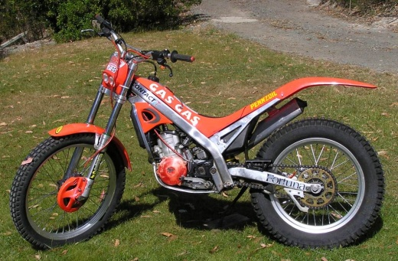

Sherco Dealer - 2nd Hand bikes available, Various Makes - See Captain Sherco (Nigel Munday)
– 0364321014 or 0419155811
Trade in considered - Photo's available of bikes - Can freight to Tas if interested

Scorpa - Gas Gas Dealer - Various 2nd Hand & new Bikes available
- See David Catt or Call 03 63295464 - Trials Magazine agent

Beta Dealer - Various 2nd Hand Bikes available - Call David Ryan A.H. 03 5664 8368

Montesa Dealer – Cota 4RT 4 strokes - Tarp Hassinen ph. 02 4329 2999

OSET Dealer – Electric Trials Bikes - John Fulton 0437 100110

Towbar Mounted Motorcycle Carrier - NEW – Call Peter Bayles
The PTR tow bar mounted motorbike carrier, designed to carry a single motorcycle. The front and rear wheel loops adjusts to suit a range of motorbikes, removable stand-up post to secure motorcycle in upright position. The carrier fits on to a standard tow bar tongue.
And when not in use the rack folds up and fits into the boot of your car.
They are finished in black powder coat. Racks weigh 15Kg Price $330 Inc GST
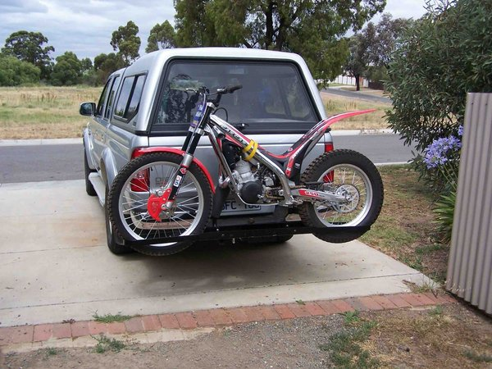


Tasmanian Trials Distributor

We are pleased to offer a large range of trials products to Tasmania.

 Distributors for: 
Gas Gas Motorcycles and Spares
Scorpa Motorcycles and Spares
Hell Team Distributor
X Pro Performance parts
Michelin, Dunlop and Vee Rubber Trials Tyres
S3 Performance products
Jitsie Performance products
Hebo and XC-Ting clothing
Airo, Nau and Hebo helmets
Trials Magazine agent
Trials DVD’s

New 2010 range of Gas Gas Bikes in stock. Scorpa models due in March.
Trade in welcome.

Second Hand Bikes available:
2006 Scorpa SY250R $4600.00 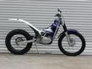
2009 Gas Gas 250 $POA (Just Traded)

Specials:
Hebo Trials Pro 10 jersey $70.00 inc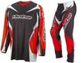
Jitsie Trial T1 Pants $160.00 inc 

Call David Catt on 0409 133 381 or 0400 872 816(Work Hrs) for all your needs.
Email: david@totalfiltration.com.au

Proud Sponsor of the 2010 Tasmanian Titles at Mt Joy 6th&7th March.
NEXT TRIAL Jericho 23 – May - 2010
DIRECTIONS – Turn west off the Midland Hwy at Jericho. Follow the signs on the 529 road 17 km on a gravel road to the Glenmore Homestead.

To Oatlands

15.0 km

Midland Highway
Jericho
TRIAL SITE “Glenmore” (Mathews Land)
2.0 Km
Melton Mowbray
6.5 km
7.4 km
529
529
A5

To Hobart

