Tasmanian Moto Trials Club inc

(The Most Challenging Motorcycle Sport)

President | Vice President | Secretary | Treasurer
Craig Ferrall | Peter Bayles | Ian Gabbedy | Mick Luscombe
0409 185991 | 0418 137967 | 0417522887 | 0408 134376

Next Trial Mt Joy – 17 Aug 2014

IMPORTANT DATES
Sunday 10 Aug – Setting trial for Mt Joy – need helpers here please.
Sunday 17 Aug - Mt Joy Trial
Saturday 8 November – Delayed Brass Monkey Ride (until after the Aussie Titles)
Sat & Sun 4 & 5 October – Australian Moto Championship

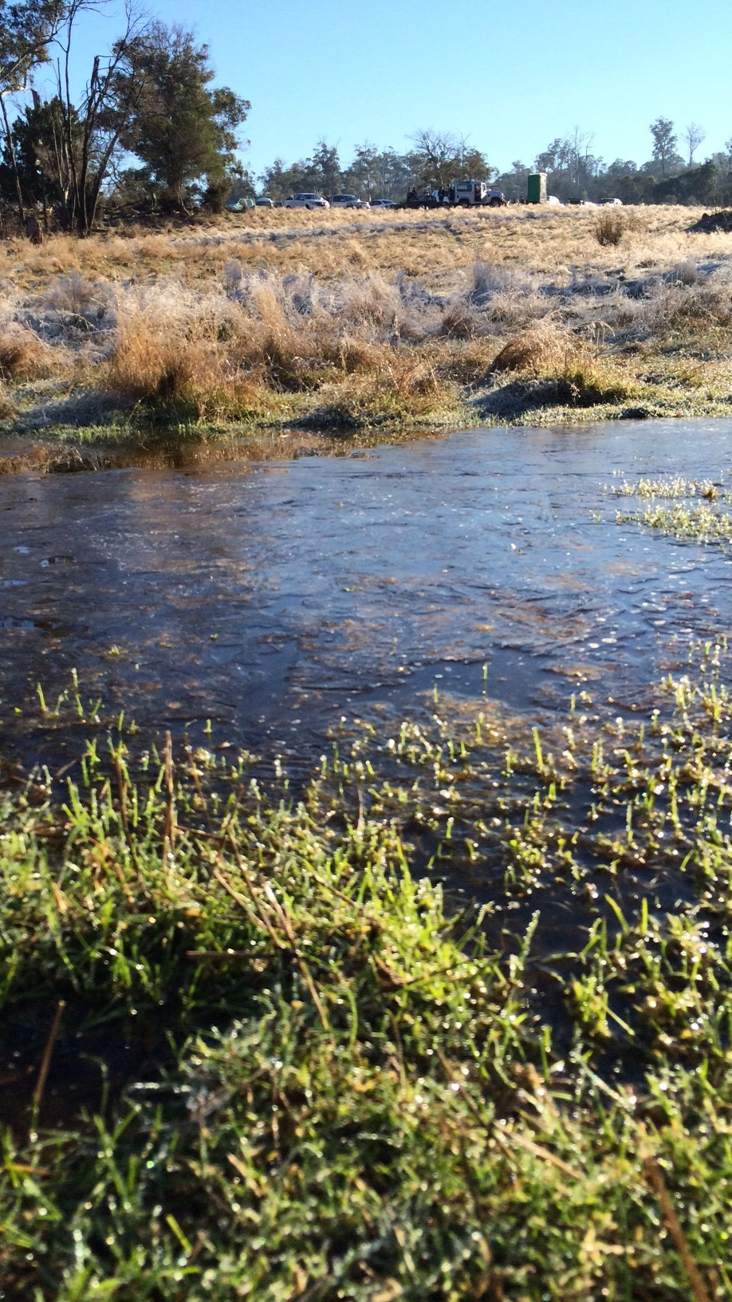
View of the Dilston site with ice in water in foreground and car park in the background.
The Dilston Trial
The Dilston trial morning was fine and frosty – but we got a lot of new faces and recycled old faces to the trial. It is very close to Launceston and is easy to access. We were on the Eastern side of the highway which now splits the old Tassie 2 Day site. The rocks on the western side of the highway are still available to be ridden as well….maybe next year.

Our talented and knowledgeable observers once again officiated firmly but fairly. We had some observers come to brush up on their skills prior to the Australian Titles in October, Dan & Rosann McLaughlan, Harvey Wynne, Colin & Christine Berne & Gracie Mae Evans. As well as regulars Brett Langworthy, Fiona Munday & Tim Mead. I know we all appreciate their work very much. The Tent was running smoothly as well with Wendy and Teena in charge. Harvey & Colin used to ride with us many moons ago, yes Colin is related to Neil Berne.

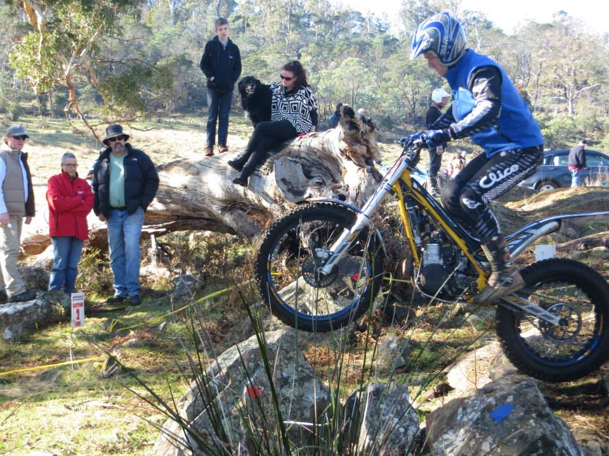
Expert Grade had one rider Brendan Smith, he had some tricky sections set requiring hopping, bouncing and short take offs as are required of this grade. Brendan is now getting quite used to his Cabestany Replica and with a slight adjustment to the carby was launching cleanly at the rocks and logs.
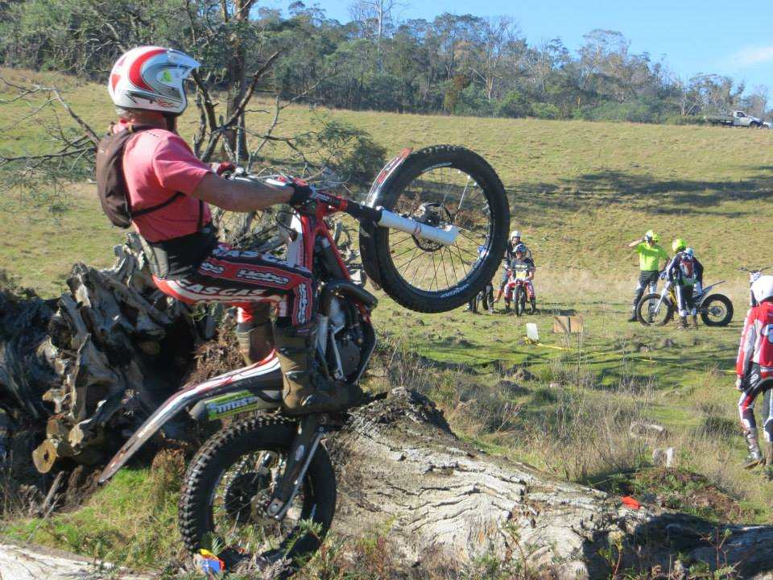

Peter Lockhart was the only competitor in A Grade, Kurt Pickering was riding a TY175 in C+ grade for this trial. Peter was riding at his leg waving best, looking like he has been practicing for the Aussie Titles. Peter was on his newer Gas Gas as there was a bit of a swing arm issue in the previous week. Perhaps the 2015 Gas Gas will have a single side swing arm as standard equipment….
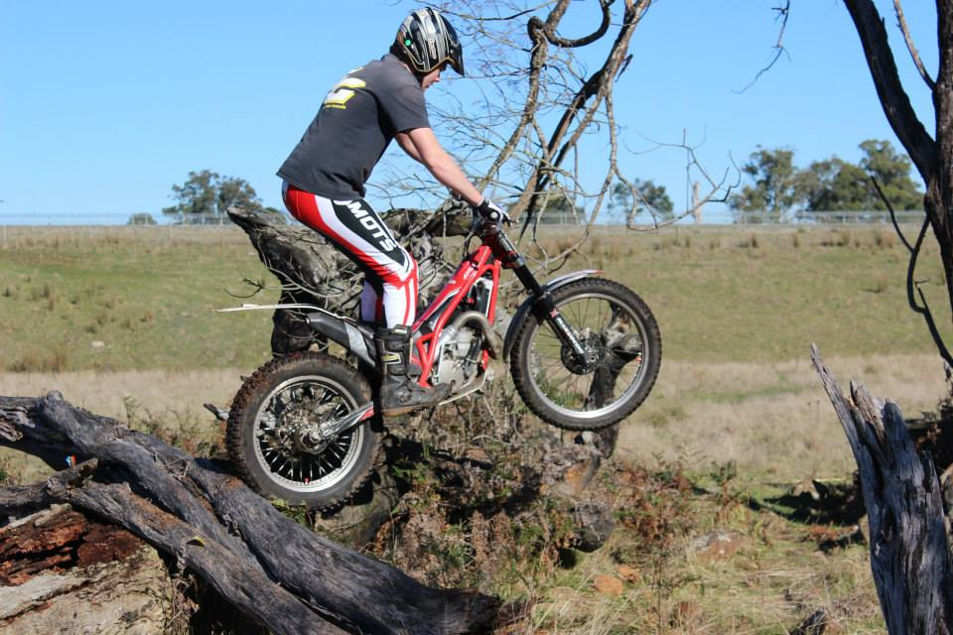
B Grade had 5 riders with Peter Bayles managing to just pip Bradley Shadbolt, who had trouble with a deflating rear tyre. I think Peter definitely knows that the competition is closing in on him. Dylan Bayles was third not far behind, and is improving now he can find time to ride his bike.

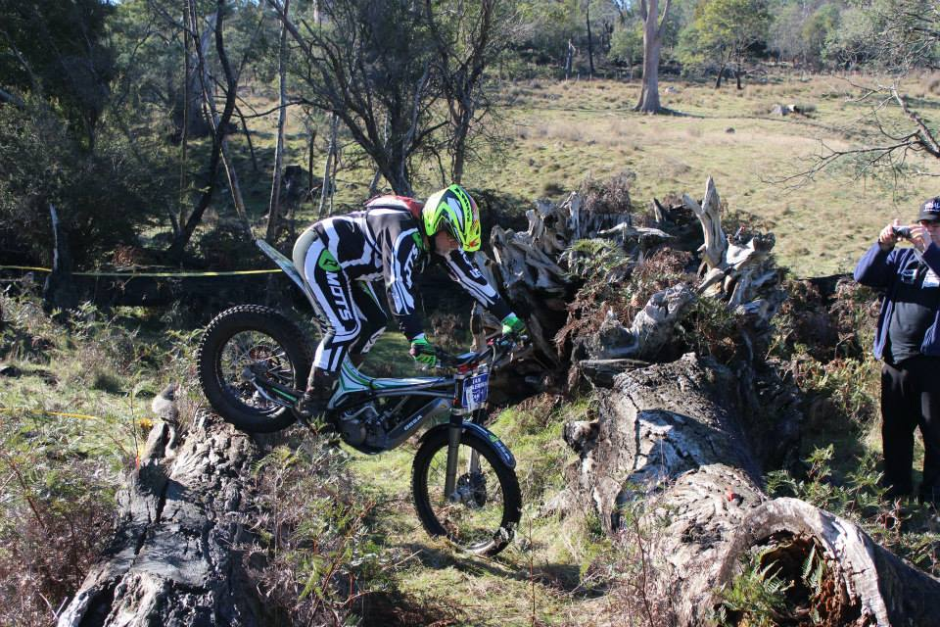
Note how Ian Pickering is trying to distract you from how he rides by wearing a new helmet !

C+ Grade was won by Kurt Pickering riding a 1981 TY175 against all the modern machinery. He is testing it out in preparation for the Aussie Titles after making some changes to it. Bryce Caletti was a clear 2nd doing the best of anyone on section 6, I suspect there was some hopping involved?? Nigel (non stop) Munday was 3rd on his new Sherco, two 5’s in section 6 were his nemesis.
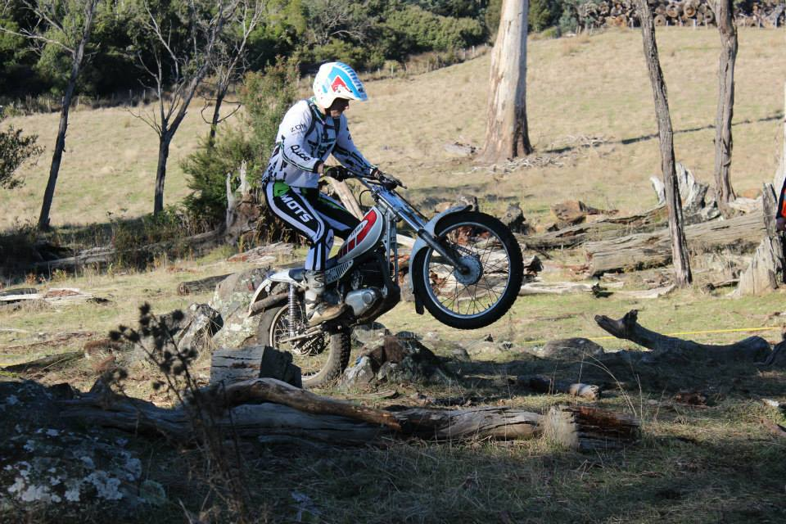

1981 TY175 vs 2014 Sherco300

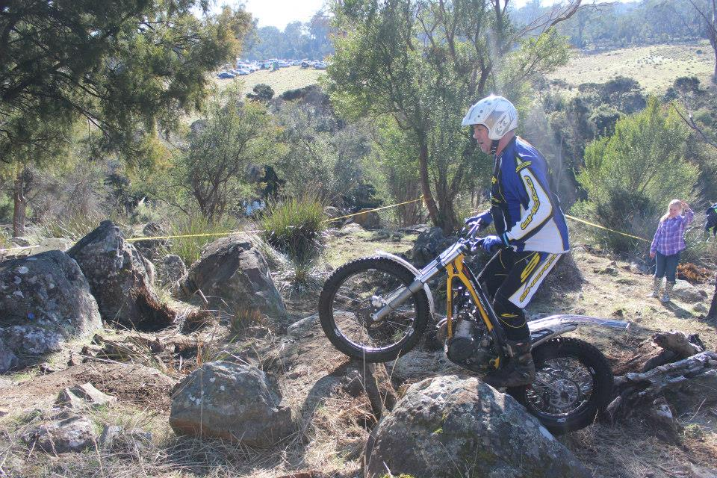
Note the trainee observer in the background

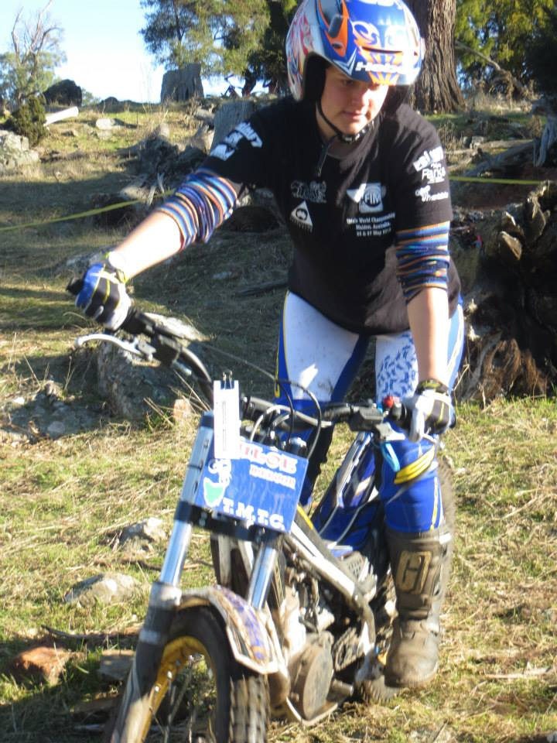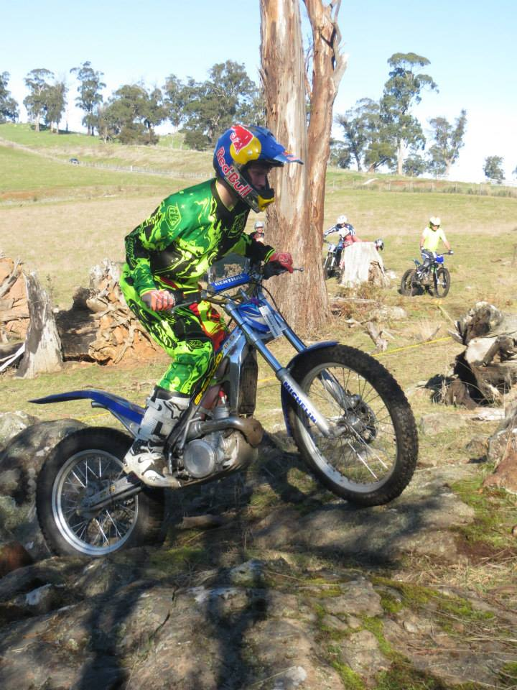

Chloe 4th …. What no finger on the brake??
C Grade had Father and Daughter competing, with Dean Medwin quite lucky to keep ahead. Mike Travica 2nd on his new sherco, still to sort out the carby settings. Andy Rouse was 3rd but only 3 points ahead of Chloe Medwin……some close competition in this class.
We welcomed some new members to C Grade, one extremely discerning rider Rob Knee who has selected an Ossa for his mount, also Gary Rush, David & Clayton Lockyer. John Barber came mid field on a Beta 80 and Jordan Perkins was riding in his first C Grade trial and going very well, until he had to DNF. Better luck next trial Jordan.
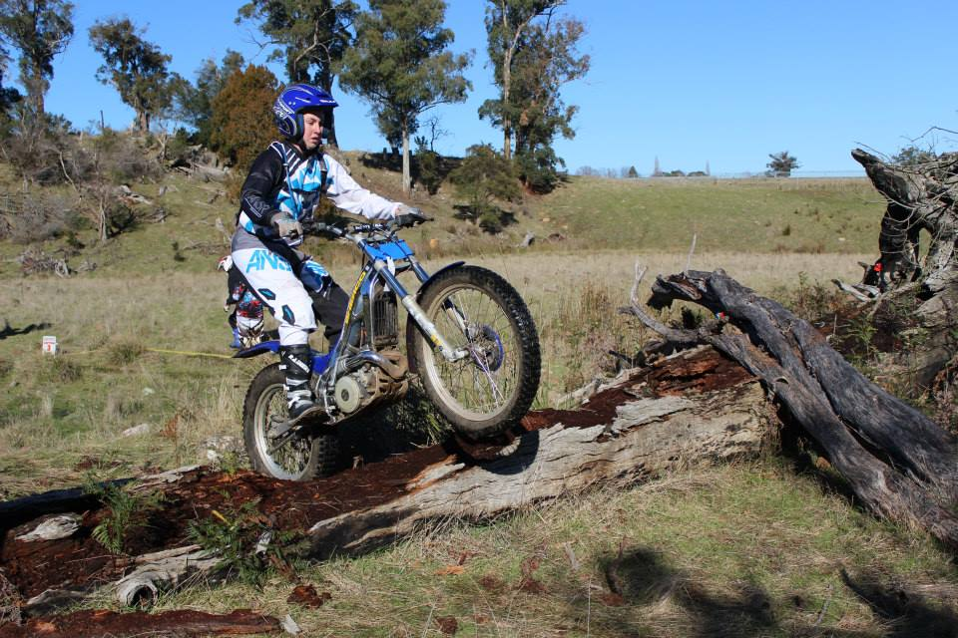 Jordan Perkins

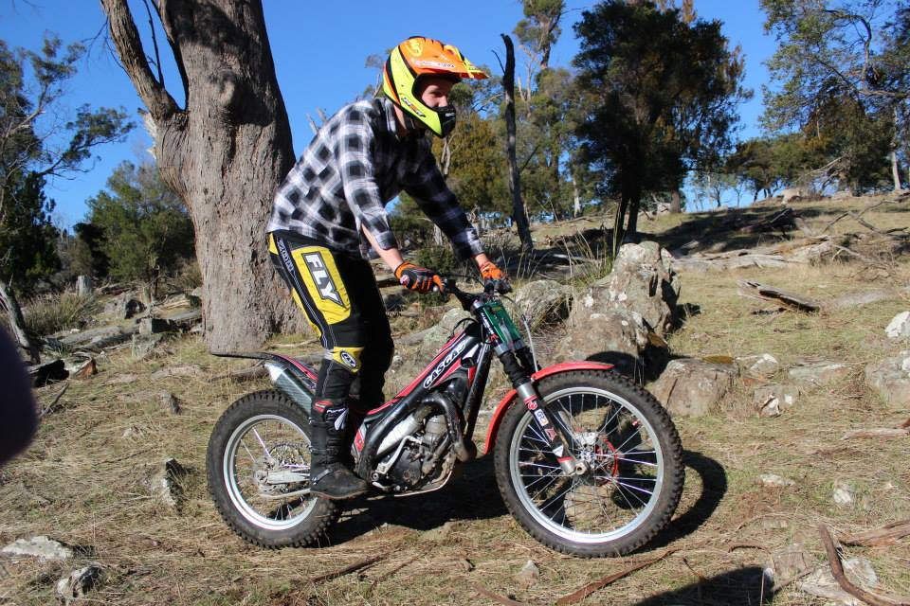 Jack Costello

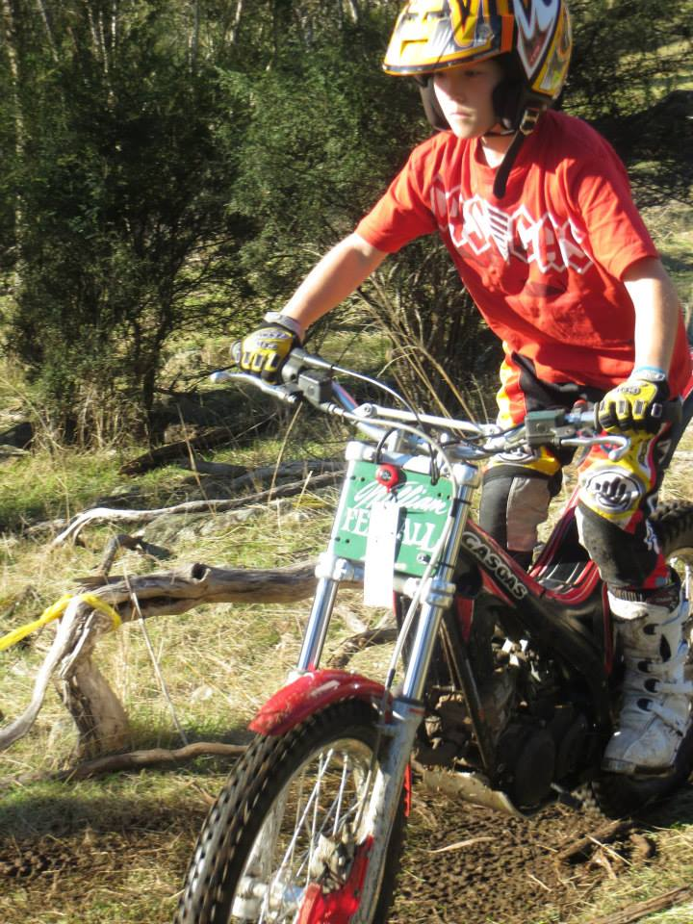
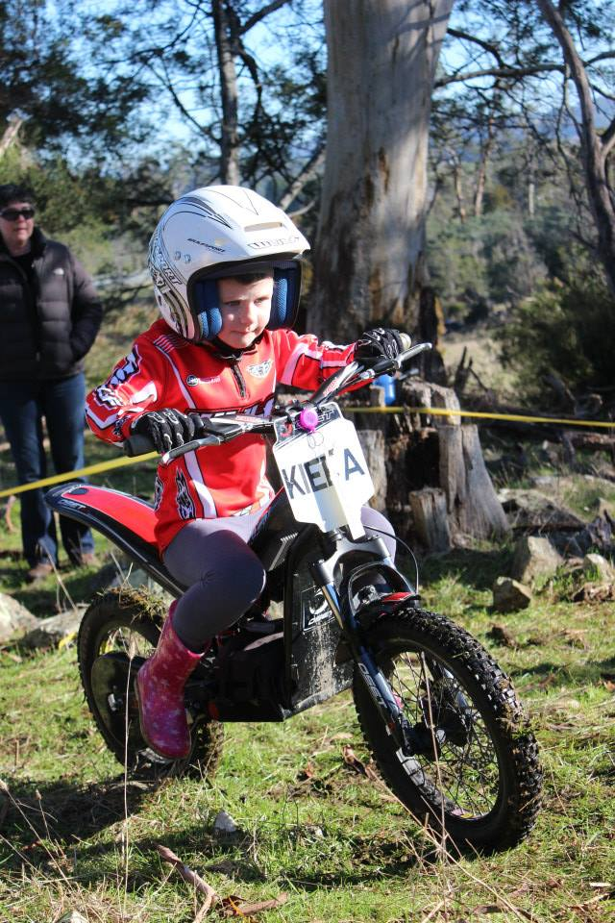

Clubman had 3 riders – Jack Costello , Broc Gabbedy & Will Ferrall competed in Clubman. Jack returning after a break from trials, trying to complete the switch from his AG100 to the 250 Gas Gas…nearly the same performance! Broc was showing an improvement in his confidence and riding on the Electric Oset. It survived the creek as well. I note the electric bikes have been included as a class in the MA manual from next year. Will looks like he has got his mechanic to sort out the carby issues he was having, now it is time to get used to the extra power from his new bike. Keira Gabbedy made a cameo appearance on her Oset bike in section 1.
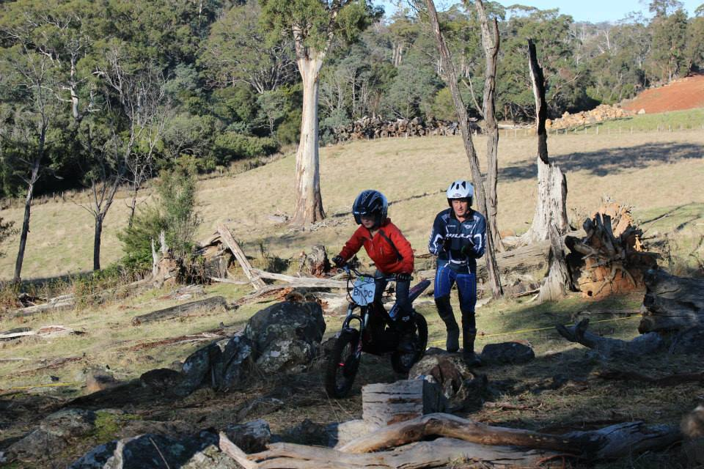

Prezz Fezz Sezz

Well it’s been a long time since we have been able to put fingers to key boards but now we have. Thanks to Toni and Ian Pickering for putting this half yearly update together.
Well the first part of the year has seemed to fly past and the big challenge for the club this year is approaching fast, with the Aust Title only 2 months away.
I can feel the excitement building we are aiming for this event to be the best Aust Title so far. A big thank you to our committee who have put so much effort in so far - but don’t panic we still have a lot to do and all members will have the chance to do their bit.

For the remaining Tas Trials, we are now on track with the Police permits for the rest of the year so we should not see any more hold ups going forward. The only thing I ask of our members, is please can we have some help with setting the next couple of trials. They are at Mt Joy and Upper Esk (Coker’s Road) as this makes 4 in a row for the Northern crew, as well as working bees setting the Aust Title. That doesn’t leave many spare weekends for mowing lawns and keeping our partners happy.

I am very pleased to see so many new members starting to come through and seeing how lucky we are to have such a good club. A club with friendly members that make every one welcome and show people why we love the sport of trials, so please keep up the good work and keep spreading the word as the more members we can gather the stronger TMTC will be in the future.

Going forward we need to start looking into the future as far as TMTC goes and start to plan a structure that will ensure TMTC remains strong over the coming years and continues to grow. So we are able to host fantastic State two day title events and future Aust Title events. We have set the bar fairly high and need to keep moving forward and not back, so please give some thought and we will cover this at the AGM at the end of the Year.

Sorry if I have been off the boil a bit with the club this year as with work commitments and a growing set of kids time has been a bit short at times, moving forward I should be able to start putting more effort towards the club.
With the end of year coming around quick we need to also start thinking about office bearers for next year if you are keen start thinking, and when the AGM comes around put your name forward. As for me I will stand for President again but only if no one else is willing to take on this role, but that is up to the members not sure if you want me for a fifth year in a row?
Well time to get back to it hope to see you all at the next trial at Mt Joy and keep an ear out for the Aust Title working Bees.

If you can assist with any task at the Aussie Titles please contact me or Ian Pickering 0418131341. There will be plenty of jobs from parking cars to observing and clicking, etc.

Craig
Prezz Fezz.

Aussie Titles News

Go to our Facebook Site for all the latest information –
2014 Chilli FM - Enzed Australian Mototrials Championships
There will also be regular updates on www.trials.com.au

Travel – Make sure you book the Boat early if you are coming to Tas !
Some good news for our mainland travelers is the TT Line have listed our event in the members area so when booking you should see some discounts depending on your circumstances. Below is the info you need. If you have already booked contact them and explain your booking relates to the event, you MAY get a fee change but it is not guaranteed. Usual story check the fine print.

Booking Info:
The URL address to your Exclusive Member’s Page is: http://www.spiritoftasmania.com.au/amtc/

When booking/amending via this page, members will have access to the best available fares on their chosen sailing dates. travellers is the TT Line have listed our event in the members area so when booking you should see some discounts depending on your circumstances. Below is the info you need. If you have already booked contact them and explain your booking relates to the event, you MAY get a fee change but it is not guaranteed. Usual story check the T and C's.This info will also be available on the trials website shortly.Booking Info:The URL address to your Exclusive Member’s Page is: When booking/amending via this page, members will have access to the best available fares on their chosen sailing dates. travellers is the TT Line have listed our event in the members area so when booking you should see some discounts depending on your circumstances. Below is the info you need. If you have already booked contact them and explain your booking relates to the event, you MAY get a fee change but it is not guaranteed. Usual story check the T and C's.This info will also be available on the trials website shortly.Booking Info:The URL address to your Exclusive Member’s Page is: When booking/amending via this page, members will have access to the best available fares on their chosen sailing dates.

Class Changes for 2014 Aussie Titles
Just a quick note on two of the classes for the 2014 Australian Title.
- MA have approved the inclusion and introduction at our discretion of a new class designed to assist riders that need a stepping stone to Open Solo.
At this stage it is a NON CHAMPIONSHIP class this year and based on it's success, may become an official class in 2015. We will be accepting entries in this year’s event.
The class is Pre Solo. It is for riders aged 22-34 on a monoshock bike, and is designed for riders that are capable of a hard B grade or better.
Riders in this age group have not previously had a class where they could ride a modern bike, unless they could compete at Open Solo level.

As this class is new we will be looking to the riders that enter to give us constructive feedback and suggestions to ensure it has the best chance of continuing next year.

Please also be aware due to the class being approved after the Sup Regs were submitted to MA it is not shown in the documentation. A separate document will be released with the Sup Regs shortly, if you enter this class just make a note on your entry form and we will sort it out.

Thanks to the trials committee at MA for considering our request and giving us the opportunity to trial it.(pardon the pun:))

- On the women's class, we have worked with some of the competitors to try and increase the entries and options for our women that ride around the country. This year we will not be splitting the class as has been done before but setting the sections differently. The majority sections will be based around C to C+ lines with a couple being set around B grade to enable our higher classified riders to be challenged. This should provide a path from Juniors to Womens Class so our young women can compete at a comfortable level, whilst also challenging our experienced women.
It is experimental but our goal is to encourage the class to grow by encouraging more riders, and thanks to Kristy for some input into this. If you want more info on this just shoot us a message.

We are excited about the prospect of more potential competitors and the growth of the sport if both these classes are successful.

Aussie Titles Status
The Committee is progressing well with the preparations and planning for this event.
The event is shaping up to be memorable so all of you that thought you could not come to Tassie to ride, saddle up and get down here, we would love to have you!!

Whilst the Sup Regs are due any day now, if you are coming we suggest you get onto booking the boat. Remember to log into the members page and look for the Aust title to pick up any deals available.

- Major Sponsors secured for this event ENZED & Chilli FM
- Northern Midlands Council are also sponsoring this event
- A location for the Presentation Dinner has been booked
- A Food Van has been hired for the event
- The access road to Mt Joy has been upgraded (very smooth now)
- New never ridden sections cleared, ready for Aussie Titles
- Marque’s for the scoring area
- Memorabilia - Teeshirts and stubbie holders ordered
- Sup Regs to be posted very soon
- Volunteers and officials are sorted nearly, (more volunteers accepted,the more the merrier).

The only thing we need now is YOU
Fun & Games at the Trial
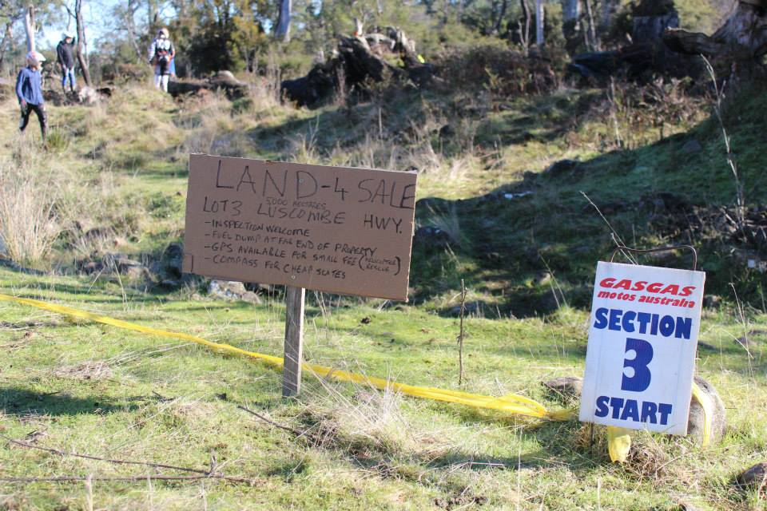
- Mick Luscombe set section 3 – quite a memory test for some riders. A bit of banter about the size of this section compared to Section 4 set by Ian Pickering. A Post Code compared to a Postage Stamp was the comparison. Both sections had their advantages….both rode well on the day.
- Ron Leistra had trouble starting his Ossa before the trial……It does help the spark if you plug in your ECU !

Fun & Games AFTER the Trial

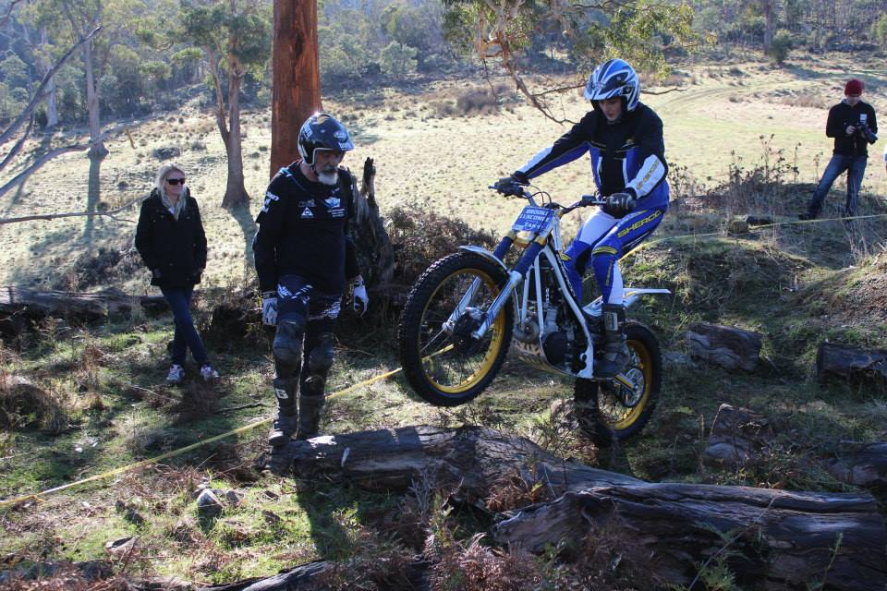

Congratulations to Brooke Luscombe & Stefan Lendvay on their marriage the week after this trial at Cradle Mountain. Brooke was being Veeeery careful not to injure herself or get bruised before the big day. I bet Mick’s speech will be short, sharp …and to the point.

.
Results are tallied by section
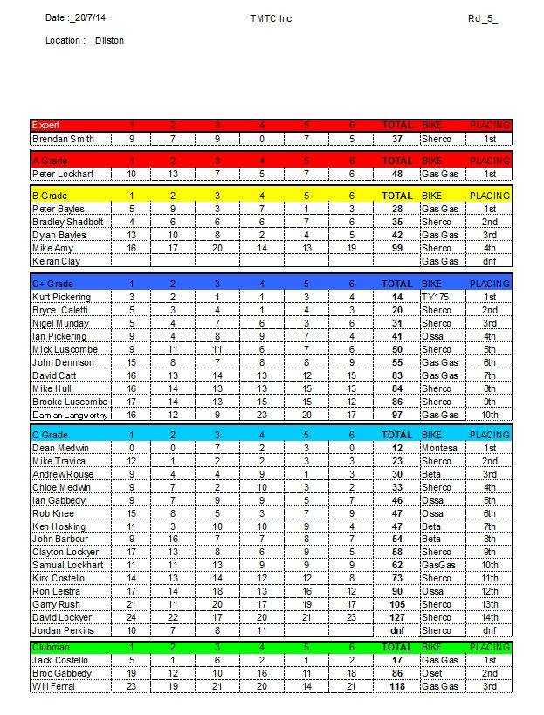
BIKES FOR SALE

Sherco & Ossa Dealer - 2nd Hand bikes available, Various Makes - See Captain Sherco (Nigel Munday) Call – 0364321014 or 0419155811
Trade in considered - Photo's available of bikes - Can freight to Tas if interested

Scorpa - Gas Gas Dealer - Various 2nd Hand & new Bikes available
- See Craig Ferrall or Call 0409 185991 - Trials Magazine agent

Beta Dealer - Various 2nd Hand Bikes available - Call David Ryan A.H. 03 5664 8368

Montesa Dealer – Cota 4RT 4 strokes - Tarp Hassinen ph. 02 4329 2999

OSET Dealer – Electric Trials Bikes - John Fulton 0437 100110

Towbar Mounted Motorcycle Carrier - NEW – Call Peter Bayles
The PTR tow bar mounted motorbike carrier, designed to carry a single motorcycle.. The carrier fits on to a standard tow bar tongue. And when not in use the rack folds up and fits into the boot of your car.
They are finished in black powder coat. Racks weigh 15Kg Price $330 Inc GST
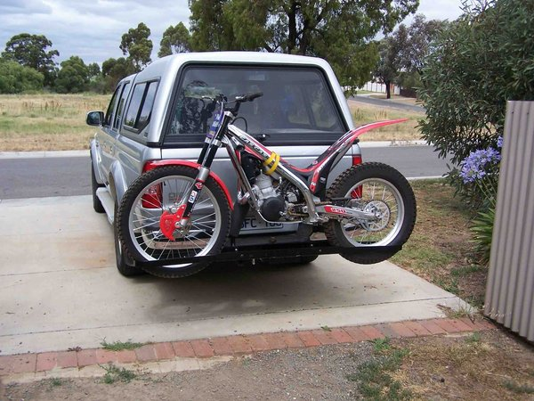

TMTC Peak Hats & Fleece Jumpers
Thanks to Teena Medwin we now have a fresh supply of TMTC Club Colour Peak Hats and fleece Jumpers.
Hats Cost $20. Jumpers are POA See Teena in the tent at the next trial…..

Next Trial – Mt Joy 17th Aug 2014
09:30 Scrutineering, 10:00am Start
DIRECTIONS – Turn west off the Midland Hwy just south of Symons Plains Raceway onto Powranna Rd (B53) and travel 7km
- Then turn South on Mt Joy Rd (C520) and travel 6km. Turn East onto a farm track opposite the entrance to the Mt Joy Homestead.
- Follow the farm track for 3km to the top of Mt Joy.
Drag Strip
Hobart
Launceston
Mt Joy Homestead
7km on B53 – Powranna Rd
6km on Mt Joy Rd

Trial Site

